1. Introduction

Natural Language Processing is applying Machine Learning models to text and language. Teaching machines to understand what is said in spoken and written word is the focus of NLP.

2. Types of NLP

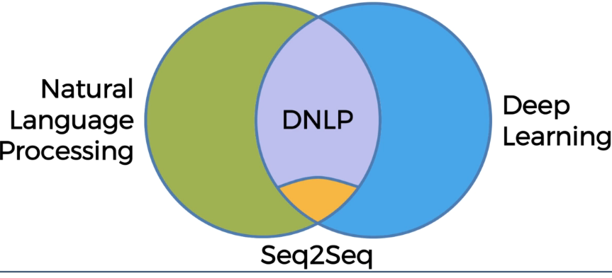

3. Bag of Words Model

Consider a vector of 0s with length 20,000. The length is chosen so because it is the average number of English words known to a native English language speaker. Each index in this vector belongs to a word in the English language. We update the value at index whenever we encounter a word in a sentence corresponding to that sentence.

For example, we have the following sentence and its vector:

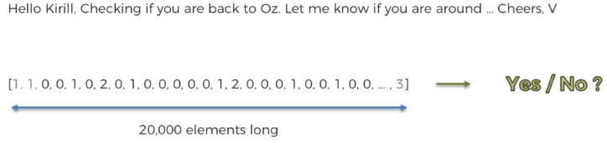

Our NLP model should automatically generate a reply based on this vector. This can be achieved by training the model on data where we had replied Yes/No to emails in the past.

Each training sentence will be converted into a vector and will be processed in the similar way as our target sentence.

One of the algorithms which can be used for bag of words model is Logistic Regression. We can also use a neural network for this process.